**Mr SGs Hydrocarbons Notes**

**Organic Chemistry**

-Organic Chemistry is the study of carbon compounds (although some simple carbon compounds are not considered organic e.g. oxides, carbonates and hydrogencarbonates)

-Carbon atoms make up only 0.2% of all atoms on Earth, but Carbon compounds make up the majority of compounds (~ 100 000 known inorganic compounds vs ~ 20 million known organic compounds)

-Life is based around organic compounds

-Organic compounds from crude oil (petrochemicals) are used as fuels and provide the chemical substances from which many of the products that surround us are based (plastics, synthetic fabrics, oils etc.)

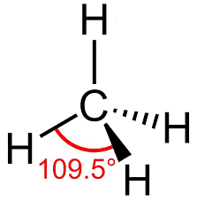

**Why Carbon?**

-Carbon has 4 valence electrons and can form 4 covalent bonds (the maximum possible number to gain 8 valence electrons)

The ability to form multiple bonds allows it to form extremely long chain and ring structures without a loss of stability

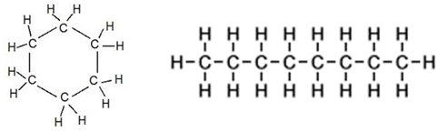

-The simplest organic molecules are those that contain only C and H (called hydrocarbons)

-Other organic compounds have a structure that is based around a hydrocarbon backbone, but with additional groups containing other atoms such as O, S, N, F, Cl, Br and I

-In Year 11 Chemistry, we will focus on hydrocarbons before studying other organic compounds in Year 12

**Structural Formulae**

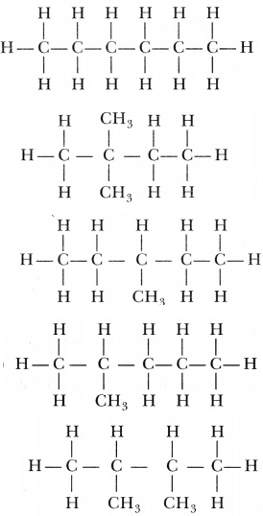

-The standard naming and formulae rules for covalent molecular substances are usually insufficient to identify a hydrocarbon

-All of the compounds in the shown to the right have the molecular formulae C6H14, but they are all distinct compounds with a different 3-dimensional arrangement of atoms and different properties

-In order to tell us the structure of a molecule, we need to give its structural formula (a formula that shows the bonding arrangement of the atoms in a molecule)

-A formulae can be called structural if it definitively shows which atoms are bonded to which atoms (it does not necessarily need to show the 3D shape of the molecule)

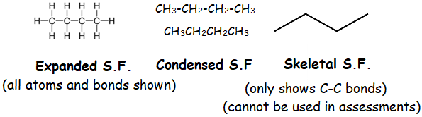

-There are also separate naming rules for hydrocarbons, which we will cover as we learn their structure

**Classification of hydrocarbons**

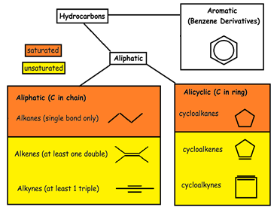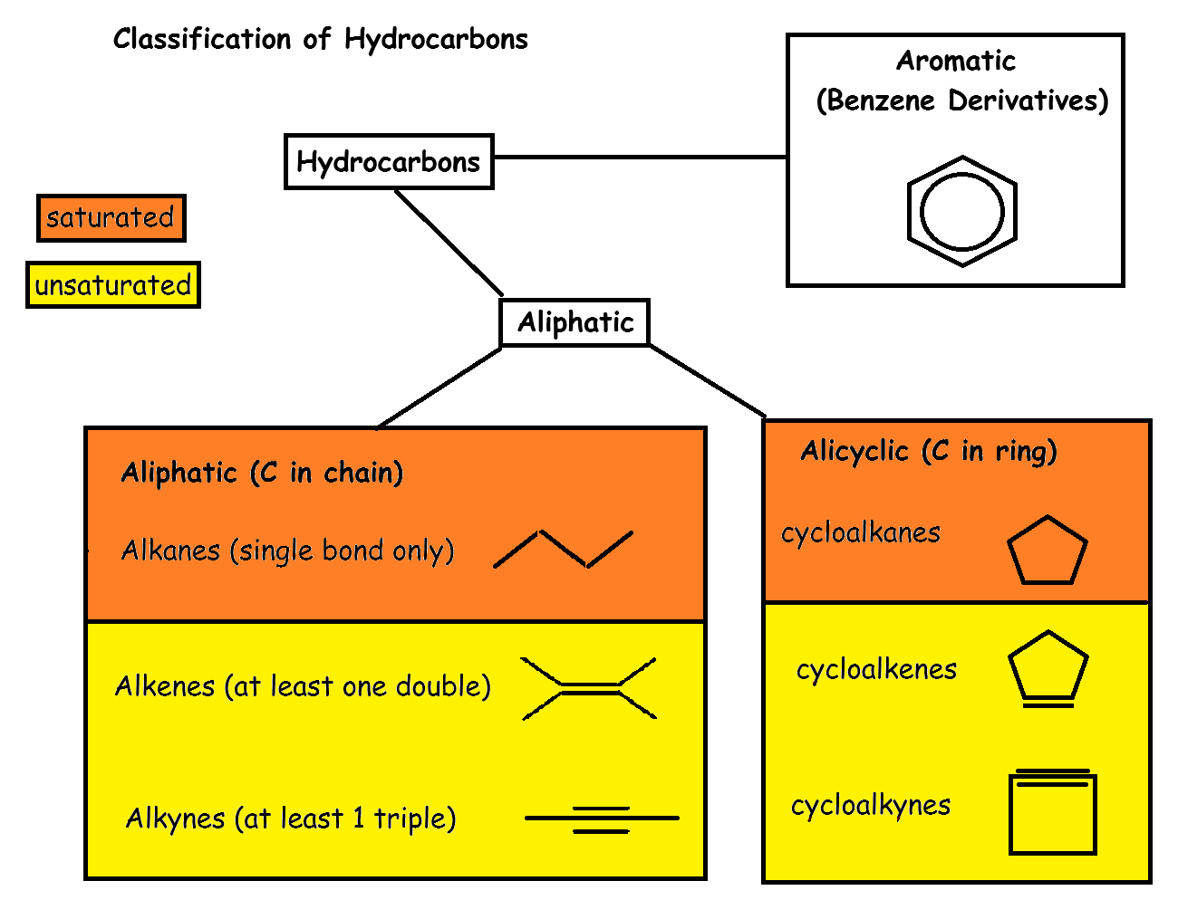

-There are a huge variety of hydrocarbons with very different structures

-They can be classified based on whether the carbon atoms are arranged in rings or chains

-Saturated hydrocarbons contain only single bonds, while unsaturated hydrocarbons contain at least one double or triple bond

-Hydrocarbons are also classified according to the arrangement of the carbon atoms in their structure (chain/ring/benzene ring)

**Structure and nomenclature of saturated hydrocarbons**

-Alkanes and cycloalkanes aresaturated aliphatic and alicyclic hydrocarbons

-Alkanes have the general formula CnH2n+2 and cycloalkanes have the general formula CnH2n

-As with all organic compounds, covalent molecular naming rules cannot be used as they are unable to distinguish structural isomers

-The IUPAC (International Union of Pure and Applied Chemistry) rules are used to name organic compounds

**Naming Rules (saturated hydrocarbons)**

-For straight chain alkanes, the name is simply a prefix for the number of carbon atoms in the chain, followed by the suffix ”-ane”

Prefixes: meth- eth- prop- but- pent- hex- hept- oct- non- dec-

(1) (2) (3) (4) (5) (6) (7) (8) (9) (10)

-For branched alkanes the procedure is a little more complicated

**Steps for naming a hydrocarbon**

* + 1. Identify and name the longest chain/ring present
    2. Name any side chains (alkyl groups) according to the prefix for the number of carbon atoms in the chain, followed by “-yl” (e.g. -CH2CH3 = ethyl)
    3. If there is more than one of a type of side chain use prefixes di, tri , tetra, penta, hexa for identical alkyl groups
    4. Number the carbon atoms in the longest chain from one end to the other, starting at the end closest to the side chains. Allocate a number to each side chain. Place a hyphen between a word and a number and a comma between 2 numbers
    5. If there are multiple side chains, they are listed in alphabetical order

e.g. 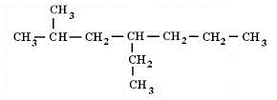4-ethyl-2-methylheptane

-For cyclic alkanes, the naming is the same, but the name starts with the prefix cyclo-

e.g. 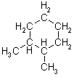1,2-dimethylcyclohexane

**Structure and nomenclature of unsaturated hydrocarbons**

-Unsaturated hydrocarbons are those with a double or triple bond between carbon atoms

-They are called unsaturated as it is possible to add additional atoms into their structure

**Alkenes**

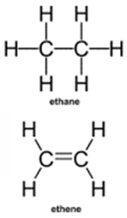

**-**Alkenes have at least one double bond and the general formula CnH2n

-They are named in the same manner as alkanes, but their name ends in the suffix “-ene”

-Because the double bond can be located in various positions, you need to include a number showing the position of the bond (unless there is only one possible position e.g. ethene, propene)

-Carbon atoms are numbered from the end that will result in the double bond being assigned the lowest possible number

-Side chains are named and numbered, as for alkanes

**Geometric Isomerism**

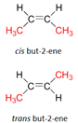

-Unsaturated aliphatic hydrocarbons exhibit geometric isomerism

-This occurs when isomers have the same structural formula but a different 3D shape

-Both isomers of but-2-ene shown to the right have the structural formula CH3CHCHCH3

**-**Isomers can have similar chemical, but different physical properties, as rotation cannot occur around a double bond as it does for single bonds

-Alkenes can exist as *cis* or *trans* isomers, where;

*cis =* main C chain/halogen atom on same side of double bond

*trans* = main C chain/halogen atom on different sides of double bond

-If a molecule can have geometric isomers, cis or trans must be included in its name

**Other functional groups**

**-**In addition to alkyl groups, organic molecules may have other functional groups, such as a halogen in place of a hydrogen

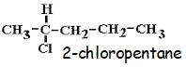

-These are named using an abbreviation of the halogen name (chloro-, bromo-, fluoro-, iodo-)

-The number and position of the functional groups are given as for alkyl groups

-If there is more than one functional group, list them in alphabetical order

(e.g. 3-ethyl-3-methylhex-1-ene)

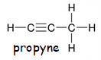

**Other unsaturated hydrocarbons**

-Alkynes are named in the same manner, but their name ends in -yne (alkynes are not in the syllabus)

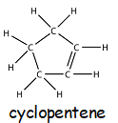

-cycloalkenes and cycloalkynes are named in the same way, but their name starts with cyclo-

**Aromatics**

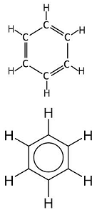

**-**Aromatics are hydrocarbons that contain a benzene ring

-They are used in biologically important molecules, dyes, plastics, drugs, explosives etc

-Benzene was isolated by Michael Faraday in 1825, with a molecular formula: C6H6 and two proposed structural formulae

-Benzene behaves as if each C has 3 bonds and the last 6 e- are delocalised (like 2nd model)

-It is a liquid at room temperature

-It undergoes substitution and combustion reactions (NOT ADDITION)

-Naming rules: the base name of benzene is used, along with the standard IUPAC rules for naming functional groups (e.g. chlorobenzene, 1,3-methylbenzene)

**Physical and chemical properties of hydrocarbons**

**Physical properties of hydrocarbons (saturated and unsaturated)**

-Hydrocarbons are non-polar, due to the symmetry around carbon atoms that results from the tetrahedral bonding arrangement

-This means that they only experience dispersion forces, the weakest intermolecular force

-This causes them to have relatively low melting and boiling points, that increase as the size of the molecule increases (dispersion forces increase with increasing number of electrons (e.g. molar mass) and increasing surface area

-C1-C4 are gaseous, C5-C19 are liquid, and C20 + are solid at room temperature

-Hydrocarbons are insoluble in polar solvents (like water) and soluble in non-polar solvents (like kerosene)

**Chemical properties of saturated hydrocarbons**

-Saturated hydrocarbons will undergo combustion and substitution reactions

-Substitution refers to substituting one or more hydrogen atoms in the hydrocarbon for another atom (often a halogen), as opposed to adding in another atom without removing a hydrogen

-“R” is used to represent a hydrocarbon in the general equations below

COMBUSTION: R + O2(g) → H2O(g) + CO2(g)

OBSERVATIONS: O2, H2O and CO2 are all colourless odourless gases

SUBSTITUTION: R-H + X2 → RX + HX

(Halogenation)

OBSERVATIONS: -These reactions are accompanied by colour changes, as halogens/halogen waters are coloured and hydrocarbons and halogenated hydrocarbons are colourless as liquids and gases (or white as solids)

-Substitution reactions occur slowly

-Substitution with F2 occurs uncatalysed, while Cl2 and Br2 require a UV catalyst (I2 doesn't occur)

- If excess halogen is present, the reaction will go to completion (e.g. all H atoms will be replaced with halogen atoms)

**Chemical Properties of Unsaturated Hydrocarbons**

-Unsaturated hydrocarbons will undergo combustion reactions, like all hydrocarbons

-They will also undergo a variety of addition reactions, where the double bond becomes a single bond and new atoms, or groups of atoms are bonded to each of the atoms that were formerly joined by the double bond

-Important addition reactions include the addition of halogens, hydrogen halides and water.

ADDITION: CH2=CH2 + X-Y → CH2X-CH2Y X-Y: X2, XH, H2, H20

OBSERVATIONS: -addition occurs more readily (uncatalysed) for halogens than substitution

-addition of water is H2SO4 catalysed

-addition of H2 requires a metal catalyst (generally Pt)

-alcohols are water soluble

**Markovnikov’s Rule**

- When a hydrogen halide is added into an alkene, two possible products could possibly be formed

e.g. CH2=CHCH3 + HCl 🡪 CH3CHClCH3 OR CH2ClCH2CH3

propene hydrogen chloride 2-chloropropane 1-chloropropane

-In reality, 2-chloropropane is the only product formed, as when addition of a hydrogen halide occurs, the hydrogen atom is always added to the carbon that is already bonded to the most hydrogen atoms

-This is known as Markovnikov’s Rule

**Empirical and Molecular Formulae for Hydrocarbons and Carbohydrates**

-The structure of an unknown organic compound can be determined experimentally, through a series of experiments and calculations

-The typical steps to determine the molecular formula are:

i) Identify quantitative composition experimentally (combustion data or % composition)

ii) Calculate empirical formula from quantitative composition

iii) Determine molar mass (M) experimentally

iv) Determine molecular formula from EF and M

**i) Identifying the quantitative composition**

-To calculate the empirical formulae of a compound, it is necessary to determine the quantitative composition of a sample of the compound (e.g. the mass of each element in a sample of the compound)

-This can be calculated from combustion data or from the percentage composition of the compound

-Organic molecules will combust in excess oxygen to produce carbon dioxide and water

-For a hydrocarbon, the number of moles of C and H in the sample can be calculated directly from the masses or moles of CO2 and H2O produced

n(C) = n(CO2), n(H) = 2 x n(H2O)

-For a carbohydrate, the number of moles of oxygen in the sample cannot be directly calculated from the masses or moles of CO2 and H2O produced, as it is impossible to determine how much of the oxygen in the CO2­ and H2O is from the carbohydrate and how much is from the O2 that it combusted in

-For carbohydrates, the mass of oxygen in the sample can be calculated by subtracting the masses of carbon and hydrogen from the mass of the sample

m(C) = (M(C)/M(CO2)) x m(CO2)

m(H) = ((2 x M(H))/M(H2O)) x m(H2O)

m(O) = m(sample) – (m(C) + m(H))

-Where the percentage composition of a compound is provided, masses of each element can be calculated by assuming a total mass of 100g and using the percentages as masses (e.g. if a compound is 21.0% carbon by mass, a 100g sample will contain 21.0g of carbon)

**ii) Determining EF**

-Empirical formula is the simplest ratio of the elements present in a compound (e.g. hex-1-ene (C6H12) has an empirical formula of CH2)

-It is determined by calculating the number of moles of each element in a sample of a compound and converting these numbers into a whole number ratio

-To calculate EF

-Calculate the number of moles of each element using n = m/M

-To convert to a ratio, divide n(C), n(H) & n(O) by the smallest of the three numbers

-If all are within 0.1 of a whole number, round them to the whole number

-If not, multiply them all by the same factor, to get them within 0.1 of a whole number

**iii) Determine M or Mr experimentally**

-This is done by determining the mass of a known number of moles of a substance (e.g. the mass of a gas that occupies a certain volume at a certain temperature and pressure)

n = PV/RT & M = m/n

**iv) Determine molecular formula from EF and M**

-MF is a whole number ratio of the EF

If MF = (EF)x x = M(MF) / M(EF)

**Example 1:** A 51.3g sample of an unknown hydrocarbon combusts in excess oxygen to produce 76.9g of water and 156.5 g of carbon dioxide. Determine the compounds empirical formula

n(C) = n(CO2) = m/M = 156.5/44.01 = 3.56 mol

n(H) = 2 x n(H2O) = 2 x (n/M) = 2 x (76.9/18.016) = 5.54 mol

|  |  |  |
| --- | --- | --- |
|  | C | H |
| n (mol) | 3.56 | 8.54 |
| /n(C) | = 3.56/3.56  =1.0000 | =8.54/3.56  =2.4006 |
| X 5 | = 1.0000 x 5  =5.0000 | =2.4006 x 5  =12.003 |
| rounding | =5 | =12 |

Therefore, the empirical formula is C5H12

**Example 2**: 15.2 g of a carbohydrate is combusted in excess oxygen to produce 22.3 g CO2 and 9.12 g H2O. The compound has a molar mass of 60.1 gmol-1. Determine the empirical and molecular formulae of the compound

m(C) = (M(C)/M(CO2)) x m(CO2) = (12.01/44.01) x 22.3 = 6.09 g

m(H) = (2 x M(H)/M(H2O)) x m(H2O) = ((2 x 1.008) / 18.016) x 9.12 = 1.02 g

m(O) = m(sample) – (m(C) + m(H)) = 15.2 – (6.09 + 1.02) = 8.09 g

|  |  |  |  |
| --- | --- | --- | --- |
|  | C | H | O |
| n = m/M (mol) | = 6.09/12.01  = 0.507 | = 1.02/1.008  = 1.01 | = 8.09/16  = 0.506 |
| / n(O) | = 0.507/0.506  = 1.002 | = 1.01/0.506  = 1.996 | = 0.506/0.506  =1.00 |
| rounding | = 1 | = 2 | = 1 |

Therefore, the empirical formula is CH2O

M(EF) = 12.01 + 2 x 1.008 + 16 = 30.026 gmol-1

M(MF) = 60.1 gmol-1

M(MF)/M(EF) = 60.1 / 30.026 = 2.002 = ~2

Therefore, MF = EF x 2 = C2H4O2

**Oil Refining**

-Humans use hydrocarbons for a number of important purposes, such as transport fuels, in power generation, as lubricants, and in the synthesis of a variety of materials including plastics, medicines and a huge variety of other products

-The majority of these hydrocarbons are extracted from crude oil

-Crude oil is a fossil fuel, produced when dead organic matter is buried under the ground and subjected to heat and pressure in the absence of oxygen

-It is a complex mixture of hydrocarbons, ranging from natural gas (one carbon atom), to bitumen (hydrocarbon chains more than 40 carbon atoms long)

-To be useful, crude oil needs to be separated into fractions, containing similar sized molecules (as the length of the carbon chain is the main determinant of a hydrocarbons properties)

-These fractions can be separated based on their boiling point, as BP increases with increasingly large hydrocarbons, due to the increase in dispersion forces.



-Crude Oil is separated by the process of fractional distillation

-In fractional distillation, the mixture is heated up until it vaporises

-The vapour rises through the column, cooling as it rises through the column

-Larger hydrocarbons will have higher boiling points, so they will cool to a temperature below their boiling point sooner, meaning they will liquefy and exit the column in the earlier levels

-Smaller hydrocarbons will take longer to cool sufficiently to condense, so they will exit the column at higher levels

-The smallest hydrocarbons are gases at room temperature, so they will remain in the gaseous phase and be removed at the top of the column

**Physical properties vs size**

-The use of the hydrocarbon fractions is based on their physical properties, which is based on the length of the hydrocarbon chain

-lubricating oils are longer than the chains in petroleum, as they need to be more viscous to lubricate effectively (e.g. they need to be longer to have greater dispersion forces to attain the required viscosity)

-Lubricating greases need longer chains than lubricating oils, as they need to be solids at room temperature

**Fuels**

-Hydrocarbon fuels (petrol, diesel, kerosene) release energy when they combust in oxygen

-The process converts chemical potential energy into thermal energy

-This thermal energy can be used to perform work, for instance by causing a gas to expand to push down the piston in an engine

-We will investigate how to quantify these energy changes in Semester 2

**Appendix 1: Naming Summary for Hydrocarbons and Halogenated Hydrocarbons**

|  |  |  |  |  |  |
| --- | --- | --- | --- | --- | --- |
| **Position of functional group(s)** | **Number of identical groups (if present)** | **Prefix for cyclic/ linear hydrocarbons** | **Name of functional groups present** | **Middle (# of C atoms in main chain)** | **Suffix** |
| -Provide a number for each functional group denoting which main chain/ring carbon atom the functional group is joined to  -Carbon atoms are numbered from the end closest to the primary functional group (alkene > halogen > alkyl group) | -di- (2) | Use prefix cyclo- if the main structure is a ring of carbon atoms | Alkyl groups:  methyl- ethyl-  propyl- butyl- | -meth- (1) | -ane (no double bonds) |
| -If multiple groups are present, list them in alphabetical order | -eth- (2) |
| -prop- (3) |
| -tri- (3) | -but- (4) | -ene (double bond) |
| -pent- (5) |
| -hex- (6) |
| Haloalkanes:  fluoro-  chloro-  bromo-  iodo- | -hept- (7) | -yne (triple bond) |
| -tetra- (4) | -oct- (8) |
| -non- (9) |
| -dec- (10) |
| -benzene (contains benzene ring) | |
| **Punctuation:** Adjacent numbers are separated by a comma. Numbers are separated from letters with a dash | | | | | |
| **Geometric isomers:** Add *cis-* or *trans-*before the name of molecules that have possible geometric isomers (cis = same side of double bond, trans = opposite sides) | | | | | |

**Appendix 2: General Equations for Hydrocarbon Reactions**

Combustion: hydrocarbon/alcohol + O2 🡪 H2O + CO2

Substitution: alkane + halogen 🡪 haloalkane + hydrogen halide (UV catalyst for

Cl2/Br2)

Addition: -HC=CH- + X-Y 🡪 -HXC-CYH- (XY: H2 (Pt cat), HX, H2O (H2SO4 cat)